# Modelling and Control of Cyber-physical systems

## Homework 1:

Results and analysis:

1. Rate of success (using grid topology):
   1. 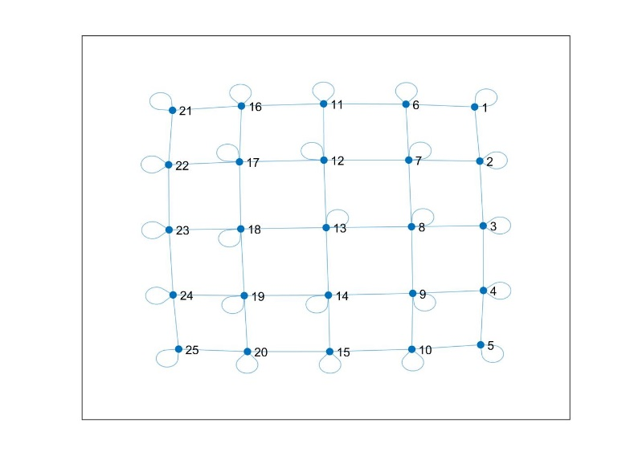IST (standard parameters on 50 tests) accuracy: 100%.   
      Average number of iterations: 9310;

Figure : example of grid topology

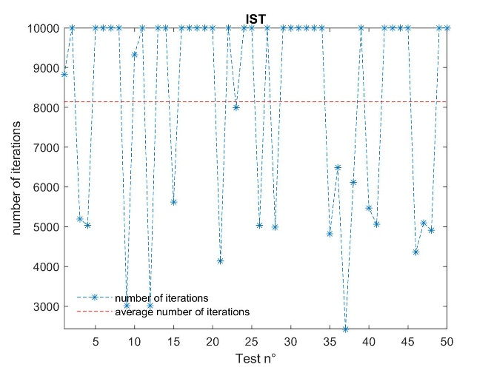

* 1. DIST (standard parameter on 50 tests) accuracy = 100%.

1. Rate of success (using random topology):
   1. 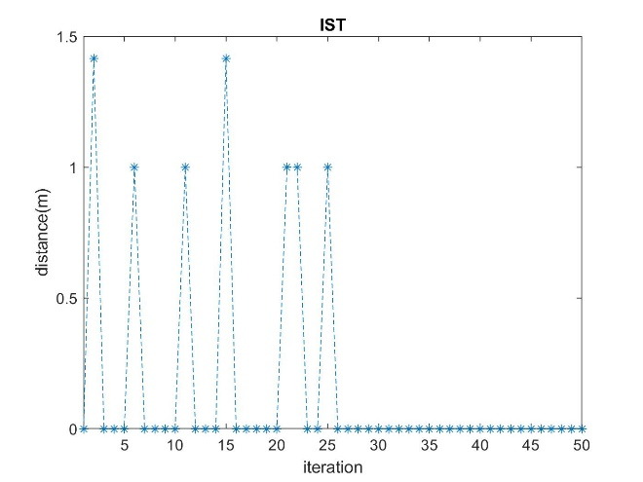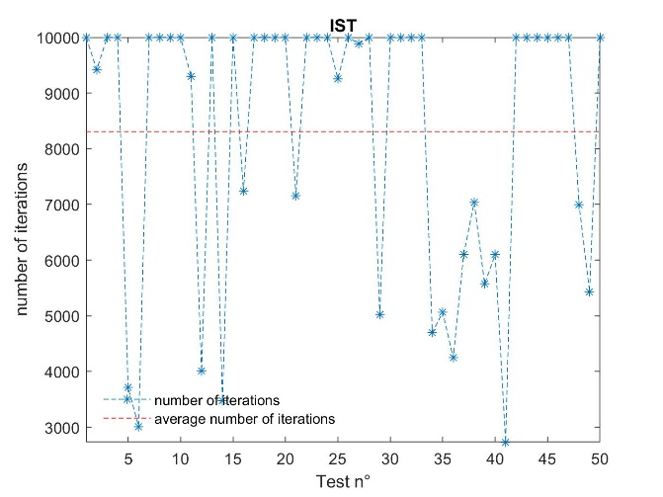Immagine che contiene testo, mappa, cielo

      Descrizione generata automaticamenteIST (standard parameters on 50 tests) accuracy: 86%.  
      Average number of iterations: 8310  
        
      Distance when unsuccessful:

Figure : example of random topology

* 1. DIST